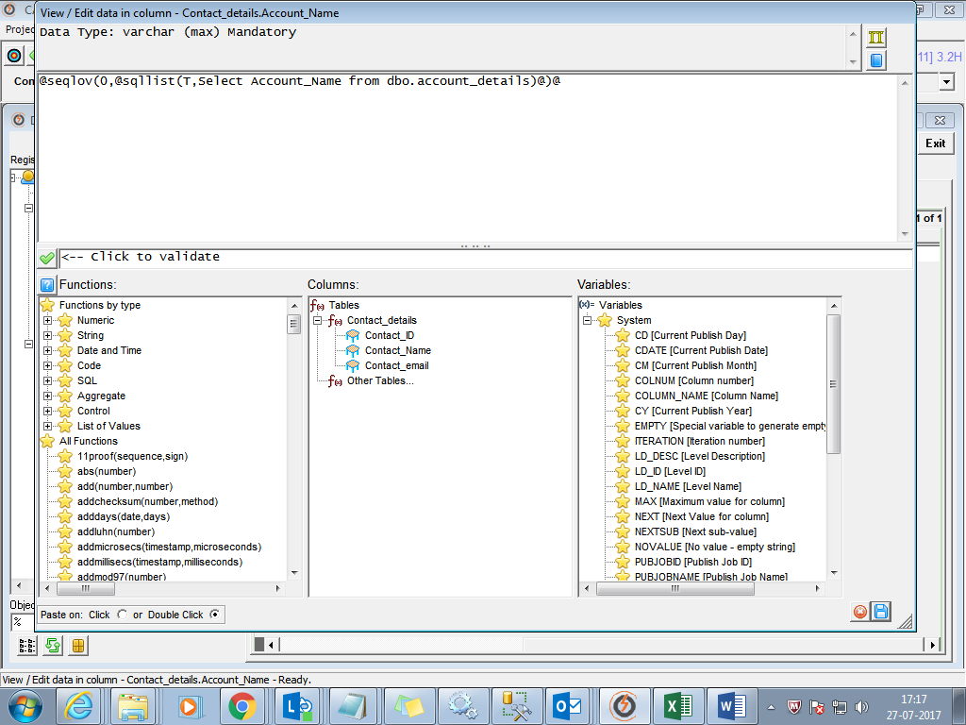

@seqlov(0,@sqllist(T,Select Account_Name from dbo.account_details,S)@)@

Create 2 table ACCOUNT_DETAILS in one db for eg orders_e and Contact_details table in another db say travel Make sure the table column Names which you are relating is same

Choose target : Orders_e

Choose Source : travel

Register table

Then

